### UML Use Case Diagram

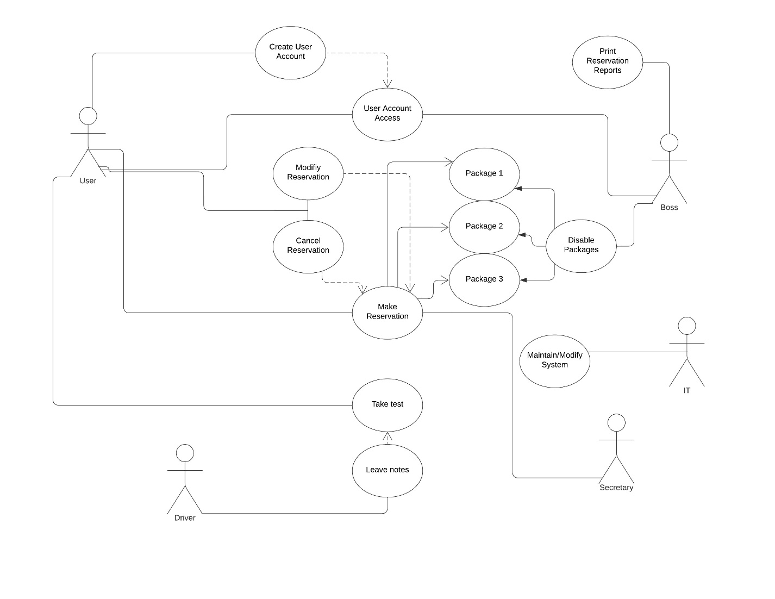

### UML Activity Diagrams

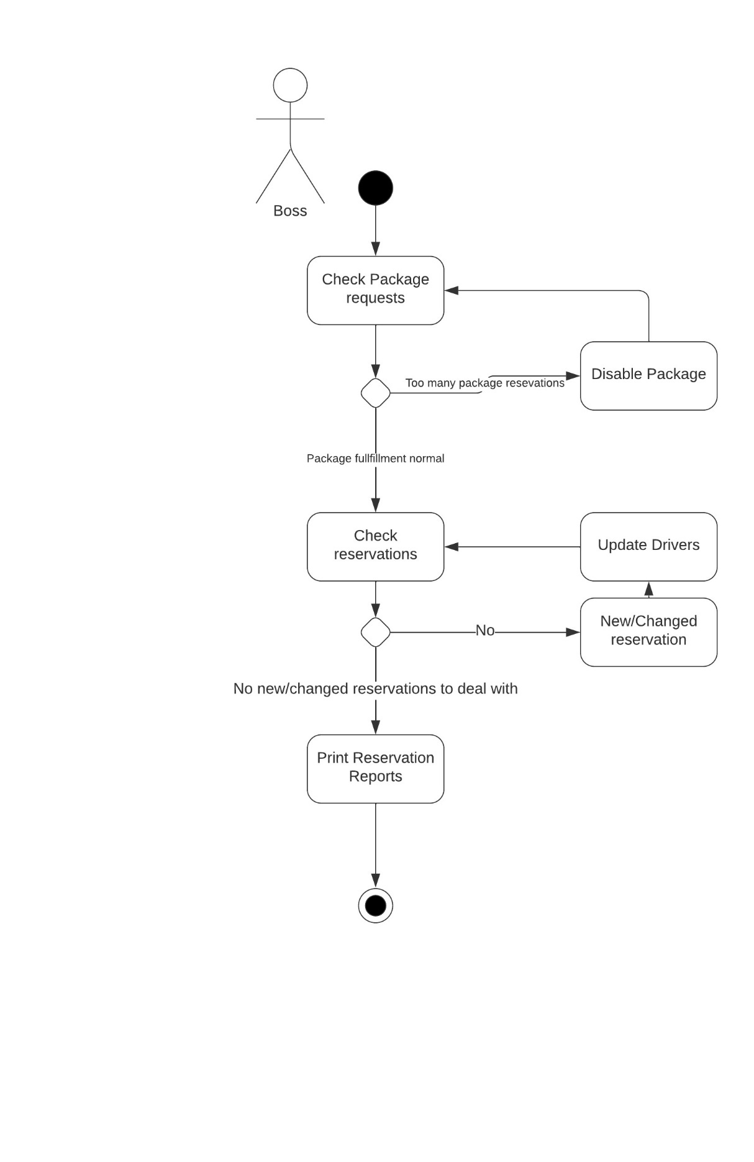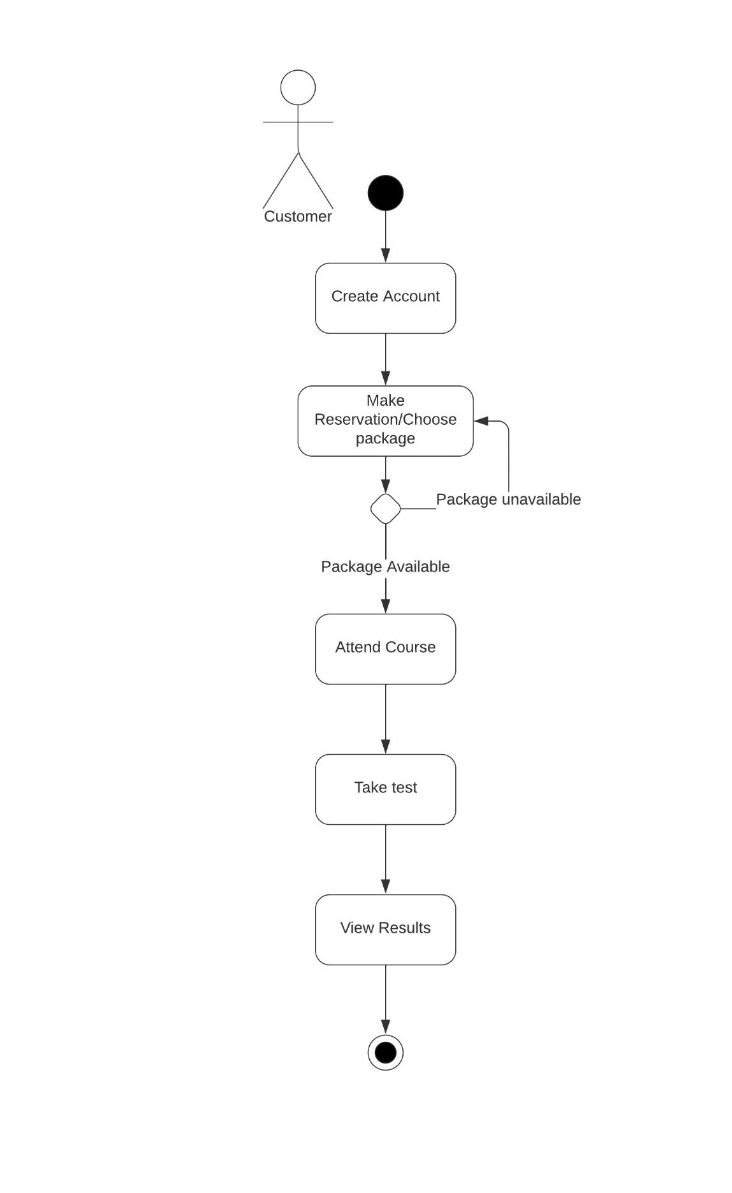

### UML Sequence Diagram

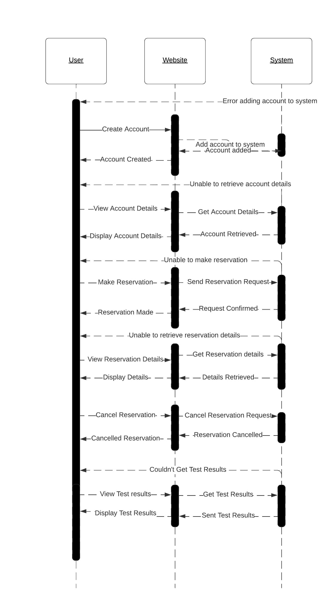

### UML Class Diagram

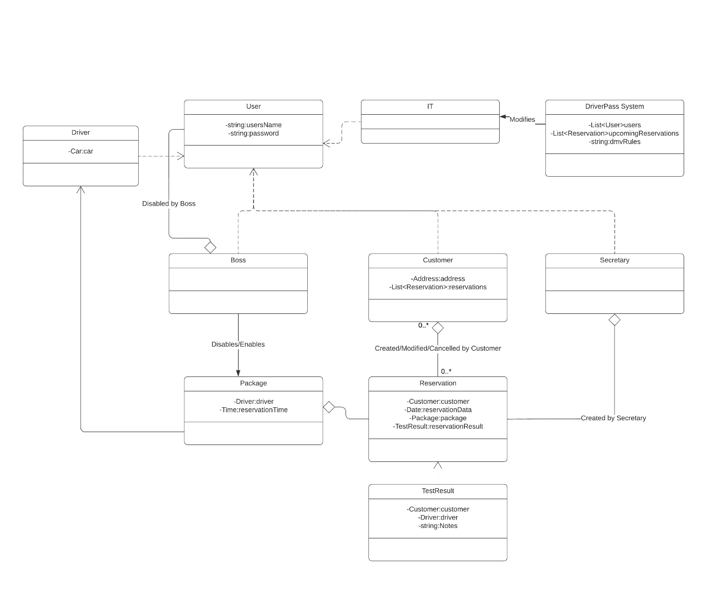

## Technical Requirements

The system needs to run off the web, preferably over the cloud, with no other specification. That means basically everything should be able to access this service. There is no specification on what other system this needs to be developed for, no specific tools need to be developed, aside from a database containing all different users, and package deals. It is a very open-ended system.